Python Queue Interaction

RISHI’s Python training

rishi.arun@yahoo.com

2021

**Types of Queue in Python**

There are mainly four types of queue in Python:

* **First in First out Queue**: For this, the element that goes first will be the first to come out.

To work with FIFO, you have to call **Queue()**class from queue module.

* Last in First out Queue: Over here, the element that is entered last will be the first to come out.

To work with LIFO, you have to call **LifoQueue()**class from the queue module.

import queue  
*# fifo = queue.Queue(size)*fifo = queue.Queue()  
lifo = queue.LifoQueue()  
simple = queue.SimpleQueue()  
priority = queue.PriorityQueue()  
  
*# Adding a message in queue - put method*message = **"This is a Message for queue"**fifo.put(message)  
lifo.put(message)  
simple.put(message)  
priority.put(message)

*# Checking Size*print(**"FIFO Size:: "**, fifo.qsize())  
print(**"LIFO Size:: "**, lifo.qsize())  
print(**"SIMPLE Size:: "**, simple.qsize())  
print(**"PRIORITY Size:: "**, priority.qsize())

*# getting the message from queue*fifo_get = fifo.get()  
print(**"FIFO :: "**, fifo_get)  
lifo_get = lifo.get()  
print(**"LIFO :: "**, lifo_get)  
simple_get = simple.get()  
print(**"SIMPLE :: "**, simple_get)  
priority_get = priority.get()  
print(**"PRIORITY :: "**, priority_get)  
  
print(fifo.qsize())

*# Checking if queue is full*fifo_size5 = queue.Queue(5)  
fifo_size5.put(**"message1"**)  
fifo_size5.put(**"message2"**)  
fifo_size5.put(**"message3"**)  
fifo_size5.put(**"message4"**)  
fifo_size5.put(**"message5"**)  
if fifo_size5.full():  
 print(**"queue is full"**)  
else:  
 print(**"you can add more messages"**)

**What is a Priority Queue?**

A queue has FIFO (first-in-first-out) ordering where items are taken out or accessed on a first-come-first-served basis. Examples of queues include a queue at a movie ticket stand, as shown in the illustration above. But, what is a priority queue?

A priority queue is an *abstract data structure* (a data structure defined by its behaviour) that is like a normal queue but where each item has a special “key” to quantify its “priority”. For example, if the movie cinema decides to serve loyal customers first, it will order them by their loyalty (points or number of tickets purchased). In such a case, the queue for tickets will no longer be first-come-first-served, but most-loyal-first-served. The customers will be the “items” of this priority queue while the “priority” or “key” will be their loyalty.

**Implementing Priority Queues in Python**

Consider that we want to have a priority queue of customers based on their loyalty points. The higher the points, the more the priority.

from queue import PriorityQueue  
  
customers = PriorityQueue() *#we initialise the PQ class instead of using a function to operate upon a list.*customers.put((2, "Harry"))  
customers.put((3, "Charles"))  
customers.put((1, "Riya"))  
customers.put((4, "Stacy"))  
  
while customers:  
 print(customers.get())

[ActiveMQ](https://activemq.apache.org/) is an open source message-oriented middleware which is used to transfer messages between multiple applications. It consists of a queue which will hold in the messages and will only transfer when the receiver is available, hence we can be rest assured that the messages won’t be lost if the server is down. The applications could be entirely different and hosted on heterogenous platforms, ActiveMQ can be used to communicate between such systems as well.

Download ActiveMQ : <https://activemq.apache.org/components/classic/download/>

Start ActiveMQ:

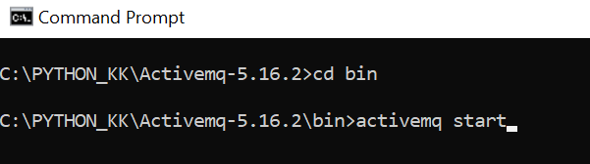

Once started click on: <http://127.0.0.1:8161/index.html>

User Name: admin

Password : admin

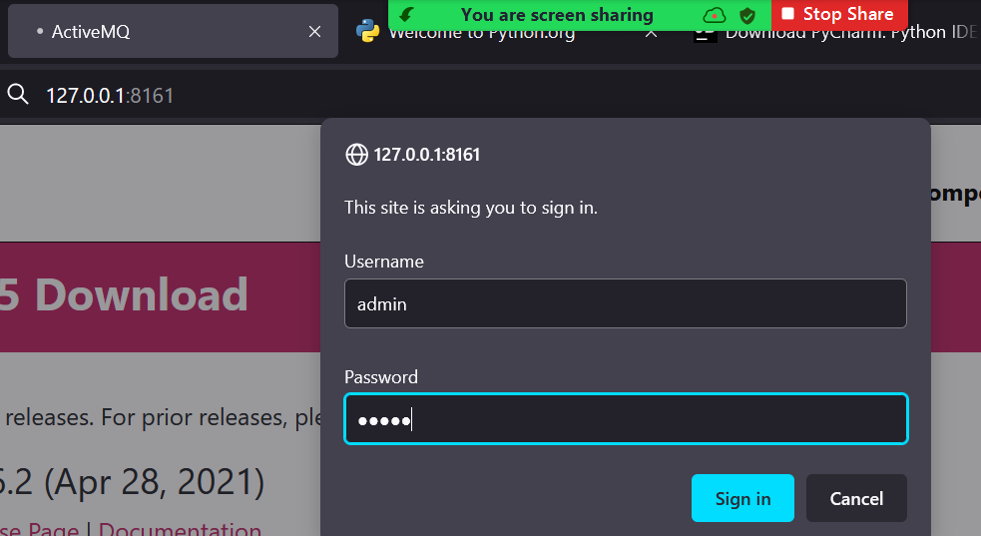

Stomp will be used to receive and send messages to ActiveMQ.

Install stmop in Python:

pip install stomp.py

**Stomp Message Sender:**

import stomp  
  
host = **"localhost"**port = 61613  
destination = **"/queue/event"**messages = 100  
data = **"Hello World from Python"**conn = stomp.Connection(host_and_ports = [(host, port)])  
  
conn.connect()  
  
for i in range(0, messages):  
 conn.send(destination=**"test.queue"**, body=data, persistent=**'true'**)  
  
  
conn.disconnect()

**Stomp Message Receiver:**

*'''  
https://github.com/apache/activemq/blob/main/assembly/src/release/examples/stomp/python/stomppy/listener.py  
'''*import stomp  
import time  
  
host = **"localhost"**port = 61613  
destination=**"test.queue"**messages = 100  
  
  
class MyListener:  
  
 def __init__(self, conn):  
 self.conn = conn  
 self.count = 0  
 self.start = time.time()  
  
 def on_error(self, message):  
 print(**'received an error %s'** % message)  
  
 def on_message(self, message):  
 if message == **"SHUTDOWN"**:  
 diff = time.time() - self.start  
 print(**"Received %s in %f seconds"** % (self.count, diff))  
 conn.disconnect()  
 else:  
 print(message)  
 print(message.headers)  
 print(message.body)  
  
  
  
conn = stomp.Connection(host_and_ports = [(host, port)])  
conn.set_listener(**'RishizListener'**, MyListener(conn))  
conn.connect()  
conn.subscribe(destination=destination, id=1, ack=**'auto'**)  
print(**"Waiting for messages..."**)  
while 1:  
 time.sleep(10)